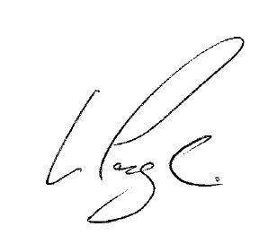

**Keighley Laboratories Ltd**

**Approved Supplier Certificate**

In recognition of achieving Approved Supplier Status,

Approval Number AS 1138 has been allocated.

This approval requires full compliance with HS Marston Aerospace Limited, Purchase Orders, Quality Standards and requirements for suppliers and subcontractors defined in company standard QA1019.

Subject to the foregoing conditions, this approval shall remain valid unless cancelled, suspended or revoked by the company.

HSM/Q60/3/10.12

HS Marston Aerospace Limited is a subsidiary company of Hamilton Sundstrand Corporation, a subsidiary of United Technologies Corporation.

The trademark Marston is under licence from IMI Marston Limited.

A. Dwight

Quality Manager

L. Page

Head of Supplier Quality

Date: 27th May 2021

Presented to

**HS Marston Aerospace Limited**

